Oyster Bay goes to Baltimore

Hegarty’s boatyard in Baltimore was the center of activity for the transformation of the Ilen from a near wreck to a fresh colourful little ship, ready to sail again. The story has been told many times in in other pages as it captured the heart of journalist Winkie Nixon. Winkie, in his Afloat.ie webpage, has kept us up to date with the story from when the Ilen arrived back in Dublin many years ago. When the Ilen was launched again, I decided to go and see her. I wanted to stand on her deck and feel the spirit of a traditional sailing vessel. The destination for my summer cruise was set.
Oyster Bay set off from Quoile on the 31st of May with a crew of twelve. It was grey and damp. My daughter Barbara had brought along her entire team from her work for a mornings sail to Strangford. It was an “away day” treat from work and had been postponed before this. I was treated by them to a great lunch in the Artisan Cookhouse in the village. The first of the Bangor ICC boats arrived alongside us at the pontoon during the afternoon. A party started as the sun came out and Strangford looked beautiful. My crew for the ICC weekend rally to Ardglass arrived, the workers all left and the party moved up to the pavement in front of the Cuan for a meal in the evening sunshine. Next morning was very foggy in many ways but as the fog and our heads cleared we headed round to Ardglass marina. The ICC Rally advance party had dinner in Aldo’s. My Turbot was as fine as the company.
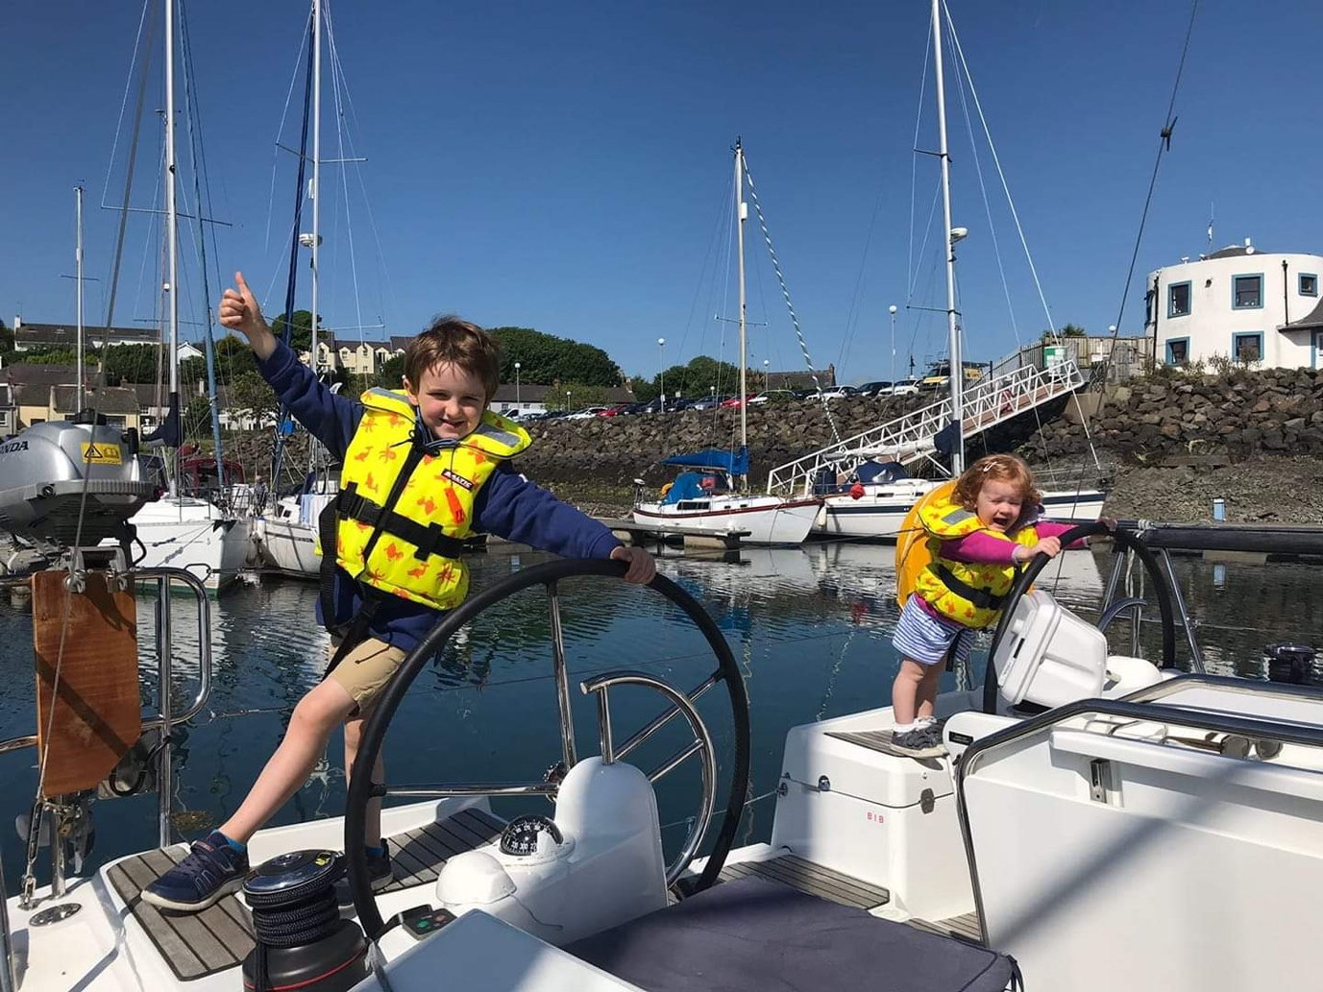
Saturday brought more fog, another daughter Rebecca and her two very young children. They wandered around the boats in yellow lifejackets captivating all our friends.
The Irish Cruising Club Commodore had a reception on the pontoon and we dined in style in Ardglass golf club. My wife Paddy as Past Lady Captain of Ardglass Golf Club agreed to pass on our thanks to the club. A sing song with a Percy French theme rounded off the night.
On Sunday 4th of June, as Bigwig with my friend Graham Chambers ICC, set off south on their cruise, I had a pause and had to return for babysitting duties on Monday and Tuesday. Rebecca and the grandchildren sailed back round to Quoile. Harry is five and Hannah is two and I hope I have them hooked on sailing with me. Duties done by Tuesday tea time, we set off again for Ardglass with my proper crew of Michael Bready and Alan Warren. A pint in Mannies helped us sleep.
Wednesday 6th. To get a long run south we left Ardglass at 6am. With not much wind we sailed most of the morning and them started the engine at lunchtime. At 1500 we passed a yacht called Bon Vivant. By coincidence, the famous Bon Vivant Neil Shand had died and I read his Obituary in the Times on my iPad. He was a very amusing man. We passed the racing trimaran Tri Logic ghosting along into Dun Laoghaire. It seemed small and frail and the solo sailor seemed quietly content in his work. They had come to do the round Ireland race. We all decided to press on to Greystones. It was my first time in the marina and again the weather was beautiful.
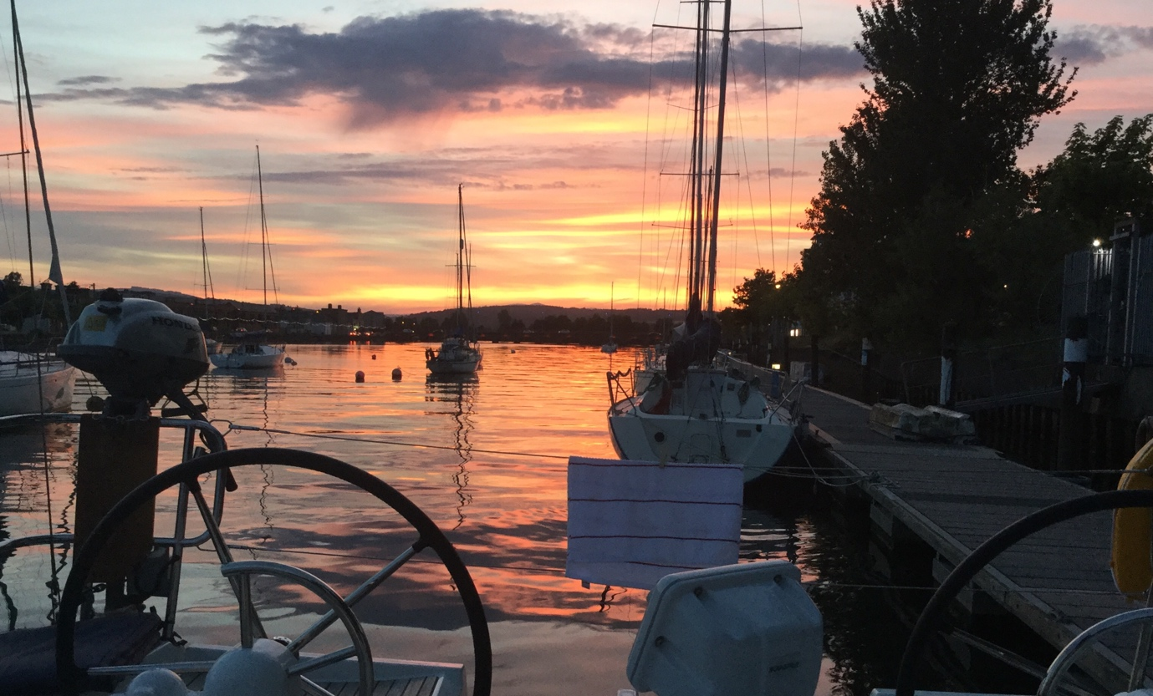
Thursday 7th. We woke up to a bright still morning, to a backdrop of tall yellow cranes. The yardarms of today building the new houses of tomorrow. 0920 we left Greystones, passed Wicklow head with its lighthouse and extra towers above. We arrived in Arklow at 1300. The fun going up the river to the pontoon below the sailing club is not where but when you will start to plough the mud. We managed to get right up to where we were going to tie up and only mudplugged while we turned the boat around to have the sunset over the stern. The afternoon was spent watching the Powerboat “All Black Racing” being launched. We were very impressed with the engineering that went into building this very fast craft. We were also very glad not to have her fuel consumption of about 200 litres per hour at about 70 mph. The boat was preparing for a number of records attempts including Cork Fastnet Cork. Our three wives send us off cruising with three pies or casseroles or lasagne. We sat down to Bridie’s shepherds pie which lasted two nights. I reckoned she must have used two shepherds! Below is Arklow sunset.
It was Friday 8thand a note on my chart showed we had last left Arklow on 3rd of June 2013 at 8am. We started earlier this time and were clear of the river by 0720. We had tea and a tidy up and with sails on and 2200 rpm, we went south at between 7 and 8 knots. At 1230 we rounded Carnsore point and kept inshore across to St Patricks Bridge. By 1440 we were moored up in Kilmore Quay. We didn’t bother with the Silver Fox this time as we had my wife’s excellent Beef in Beer stew. The GSI survey ship Mallet came in and moored up close to us. Crew member Rose gave us a guided tour of the ship and the wheelhouse with all its hi-tech survey gear. It is like the Starship Enterprise. They also have two Red Bay RIBs for inshore work.
On Saturday 9th I was up early to get supplies and had a long walk to the grocer. He was very unhappy as he had suffered yet another power cut and ESB wouldn’t compensate him for lost food when his freezers went off. I bought bread and with shore power we had toast from the toaster to calm us after a very noisy night with fishing boat movements in the harbour. Kilmore Quay is a very busy fishing port so noise at night is to be expected. 0945 we left in bright sunshine and no wind. The log counted down the miles to Hook head.
1140 we were inside Hook head with its pretty lighthouse and loads of pots. By 1200 Loftus Hall was to Starboard. The log noted the score as we listened to the Ireland Australia rugby international. By 1305 it was all over as we passed Cheek Point. Ireland had a try disallowed and lost narrowly. 1330 was decision time, Kings Channel or Queens Channel. We stayed in Queens as its shorter and we felt a bit flat after the match. Waterford in the summer sunshine was a fantastic destination. I last sailed up the river in 1971 and it had changed a bit. We met a lovely couple with a Jeanneau Prestige who looked after us and asked us if we needed fuel. Like Alan, he was a Mini Cooper S fan. They recognised Alan as we had competed against them when I was navigator in our rallying days. Their oilman was coming with a load of fuel for them and we were able to top up also. We walked up the town, had three concerts, Jazz, Rock and Classical Guitar, bought books in the second hand book shop, had lunch in hot sun before I took the others to see the Viking museum and the old wine cellars from 1450AD. Alan even managed to get a haircut. Waterford is my favourite historic town. We cast off from the pontoon at 1700 and had a glorious cruise gently down the river. We picked up a mooring in Dunmore East at 1945. There was a cruise ship coming in next morning so we couldn’t tie up to the new pontoon. We were disappointed not to eat ashore but there was the making of a good Ulster fry in the fridge.
Sunday 10th was grey and there were big tour coaches lined up abreast at the end of the pier. As we motored out at 0705, we passed the tenders from the huge cruise ship The Seven Seas anchored off. The tenders were stuffed with passengers for the coaches. The pontoon allowed these passengers an easy way ashore. The passengers staying on board were in the grey gloom. An hour later we were in the sun off Tramore Strand. I was tempted to suggest to Seven Seas that they move along to Tramore into the sunshine but I didn’t bother. The breeze picked up and allowed us to sail. 1400 we called up Bigwig ahead of us to see where they were. They were off Rainey Point so we decided to head on to Kinsale. We tied up astern of them at 1700. We were welcomed on board with Aperol spritzers before heading up the town to find a suitable pub. Somehow we landed into Tads Tavern in time to enjoy Guinness from Wee Mary and the Prologue of the evenings Ghost tour. It was hilarious. Back on board Bigwig, we had a convivial evening with food and wine. Woke up next morning with Yannicks Mini Transat 491 alongside us. He had come round from Galway in just 30 hours. Amazing wee boats if very scary.
Monday 11th morning was quiet. We said farewell to Bigwig who were heading west and to Agnes Roma who had been with us in Kilmore Quay. We left at 1230. By 1600 we were tucked up in the comfort of RCYC at Crosshaven. It was very quiet in the bar also. We met up with the crew of Rockstar a large CCC yacht who had left the Clyde last August and were nearly back home after an Atlantic circuit. Alan chatted to them about the state of the Caribbean islands where he had lived as a child and which they had visited.
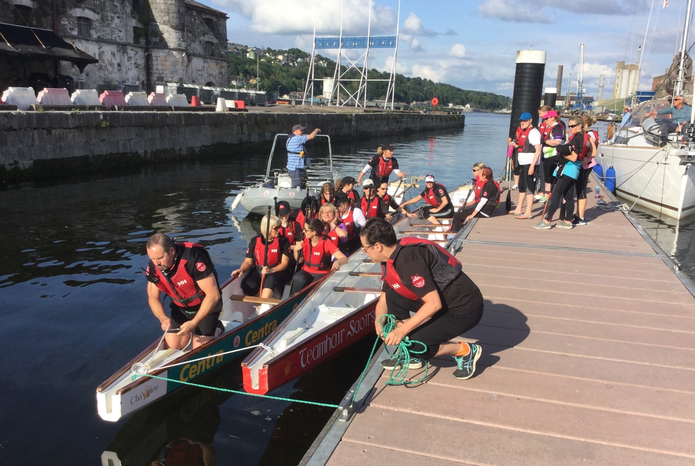
Tuesday 12th . Alan had planned to get the train from Cork back to Belfast. We decided to sail up to the pontoon in Cork city and stay overnight so Alan could walk round to the station in the morning. It was a great idea as Cork city in the sunshine was beautiful. We called the harbour office for permission to proceed up the river. When we arrived, Nick Burke, Deputy Harbour Master, was waiting for us on the pontoon looking very official. When I had phoned I had given my name Peter Mullan to the lady on the phone. Nick had thought I was another person and we had the VIP welcome. Smiles all round as the misunderstanding was sorted out. We dandered up the town to the English Market for supplies and for afternoon tea. We were well stocked for the week ahead with foodie goodies. We met a butcher who had been teed up to talk to Prince Charles and Camilla who were to visit the next day. He was excited by the prospect. Whether the royal visitors would understand much of his very strong and rapid Cork accent, I don’t know because I didn’t. Oliver Plunkett Street in Cork was a real find for model maker Alan with its many craft shops. Michael and I were very patient as the weather was so good. We had an early tea onboard as the Dragon boats were training later. I spoke to Trevor who is ex Glenans and was helping manage the boats. Some of the all girl crew were from a Breast Cancer Survivor group. They did look fierce in the dragon boat. The racing was great therapy which they all enjoyed. There is great construction going on along the river. We watched a crane driver on the building opposite the pontoon climb down ten floors before heading home. He needed a pause before setting off. We often think of the perfect anchorage in terms of its peace and quiet but the city stop was full of buzz and energy. Waterford and Cork city stops proved this perfectly. After the Dragon boats had cleared away, we wandered round to Goldbergs pub across the river. This was the old Jewish part of town and was full of music and young people. Early to bed as the builders would be starting early.
Wednesday 13th. We wished Alan safe journey home on the train. Cork City had one more surprise treat in store for us. Michael and I walked the few steps up to the Port Authority offices to pay our marina dues. The offices are very grand and its such a pity they have to move out. Nick Burke appeared again and gave us a guided tour of the main meeting room. It is a magnificent room. He says it will be preserved and I asked if we might be able to ask to have our out of town committee meeting there in the future. He said he hoped it would be possible. We met the Harbour Master himself and discussed shower blocks near the new pontoons here and there in west Cork. I suggested he look at the very simple but good facilities in Greystones marina. It was a very friendly meeting. The pontoon at Customs house quay was originally supposed to just be a set down pontoon. There are facilities available to visiting sailors at the Clayton Hotel leisure complex. There are disused bonded warehouses alongside the quay. These are inhabited by swallows swifts and a few herons. There are plans to redevelop them as fab apartments with a new tall building at the end of the quay. The Port Authority is to move to Ringnaskiddy and will leave their present offices.
We left Customs house Quay ay 1030 and set off down the river. There were many people out on the river in single sculls. They looked like little men balanced on long matchsticks. We made sure to make no wake to disturb their pleasure. The last time I sailed down the river was on Lord Nelson on the Tall Ships Race to Belfast in about 1991. Michaels nephew was on the Malcolm Millar. This time Michael and I stopped for lunch at the Pontoon at Cobh. We had sailed for a while until the wind came on the nose again. As we both come from Belfast originally, we had to stop at the Titanic exhibition at Cobh Visitor Centre. Back at RCYC we met the crew of Jocana from Carlingford lough. I started my sailing at Killowen so we had many friends in common. There was excitement in RCYC with the possibility of Royal visitors next day. In the event they went to the Naval station at Haulbowline instead. Back on board, there was a forecast of 40knot winds overnight. I checked warps and fenders and saw some very strange lights across the river. They were red and blinked and looked like giant foxes eyes. Eventually I could see they were lights on electricity wind turbines and the rotating blades were making them blink. Too much hospitality in Royal Cork.
Thursday 14th was a rest day so we read books. At our age rest days are essential.
The Friday 15th morning bus took Michael back to Cork to get the train for Dublin. I went with him as far as Carraigaline, changed to the bus back and found it went via Myrtleville. I now know where the UK sailmakers loft is hidden. I did a mega clean on the boat for my wife Paddy and daughter Barbaras arrival. They came down to Cork by car. A retail therapy session and lunch at Kildare shopping centre had them arrive just in time for me to have the boat spotless. Crosshaven was picture perfect, a perfection only improved on by glasses of Prosecco. We drove back into Cork for dinner and afterwards collected Son in Law Fin from the late bus from Belfast.
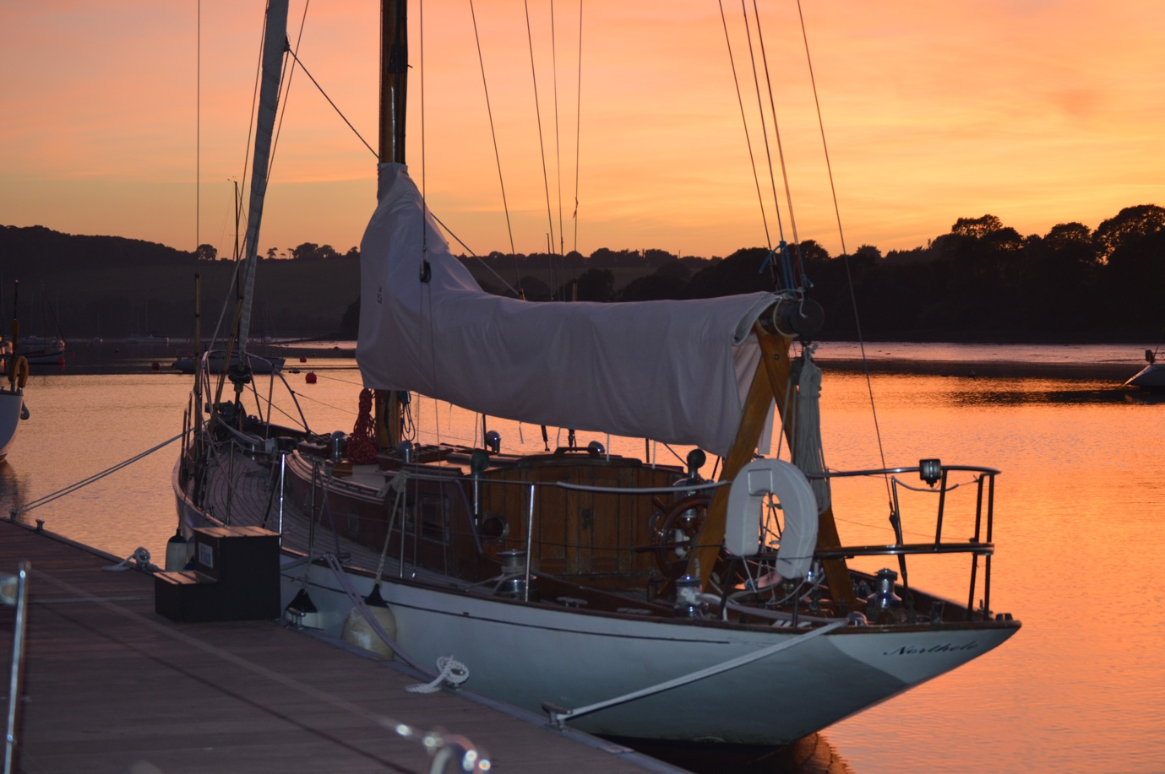
Saturday 16th brought too much wind for the ladies so we all went by car to Kinsale for lunch and more shopping. For the evening, I had reserved a table for us at the Seafood banquet at RCYC, prepared by the Lady members. It was excellent.
Sunday 17th took us back into Cork by car for more sightseeing. I took the crew back to Goldbergs for lunch and then round to Bunnies at Myrtleville for cappuccino. They loved the setting looking out over Cork harbour approaches. When we got back to the boat, we found The O’Learys new boat Northelle tied up beside us. As first classic sail to finish in the Classic Sail race, they needed to celebrate but they had no corkscrew. I gave them a present of one. It was the very first present for their new boat. Built by Berthon in about 1959, Northelle is a true classic.
Monday 18th saw the next crew change. Family all went home with car stuffed to the roof with shopping. Chris arrived from Belfast by train and bus. Colin flew in from London and arrived by taxi. Both of them have sailed with me before on cruises to Scotland. The football had started so we watched England beat Tunisia and dined in the bar. Chris is originally English so he was happy. We both love watching all sports on TV in our leisure time. With the demands of our families at home, we don’t see much. On this cruise we intended to binge watch when we were not sailing.
A leisurely start on Tuesday 19th saw us leave Crosshaven at 1100. Wind on the nose and very poor visibility. We had Bad Company for company and were glad to follow them. They were the only thing visible in the low cloud. We passed them and they followed us, making their steering easier. By 1300 we were off the Sovereigns and by 1400 we were tied up on the outside of the pontoon in Kinsale. My instruments were not displaying windspeed. By chance we met up with the MGM Boats team but they also could not get it fixed. Back to guesswork. KYC is lovely. Very welcoming to visitors and out the back is the White Lady hotel. Good for food. In the football, Russia beat Egypt so Mo Salah was not happy.
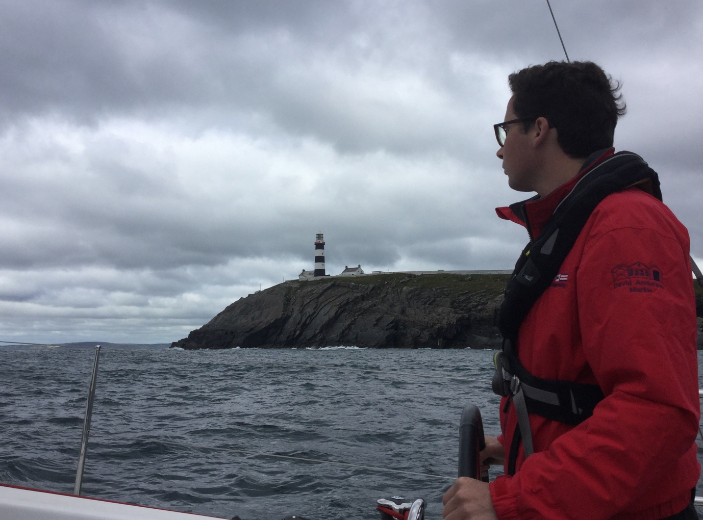
On Wednesday 20th morning, Fran from MGM came down and went up to the top of the mast. He also was unsuccessful in fixing windspeed so we cIeared the harbour by 1000 on our way west. 1100 saw the Old Head,
Old Head of Kinsale.
1200 Seven heads, 1300 Galley head and by 1400 we were off Glandore. During this time we were very slowly overhauled by the 40 foot long French Racing yacht Tocatto. As we are only 36 feet hull length, we felt we were doing very well at our maximum hull speed. 1500 off the stags and 1600 on Baltimore pontoon. The Baltimore pontoon is an old ship surrounded now by new garden decking. It’s a bit rough but very welcoming. The mooring cleats are definitely a bit of overkill. To get some exercise, we walked up to Lots wife. Stunning views. Locals take the scenery for granted, we visitors were blown away by the beauty of it all. I must have been very tired as log just says “Pizza Pints Bed” In bed, I fished out my books to plan the next days visit up the river Ilen to Oldcourt.
Thursday 21st tides could not have been better. With HW 1230 at Oldcourt we just had to leave at 0945 to arrive at 1100. The chartplotter and Navionics on the iPad agreed with Norman Keans directions in the Irish Cruising Clubs Guide to give us a troublefree trip up the river on a rising tide. We tied up close ahead of the rusty Trawler and went ashore to find Liam Hegarty. He made us most welcome after our long voyage to meet him.
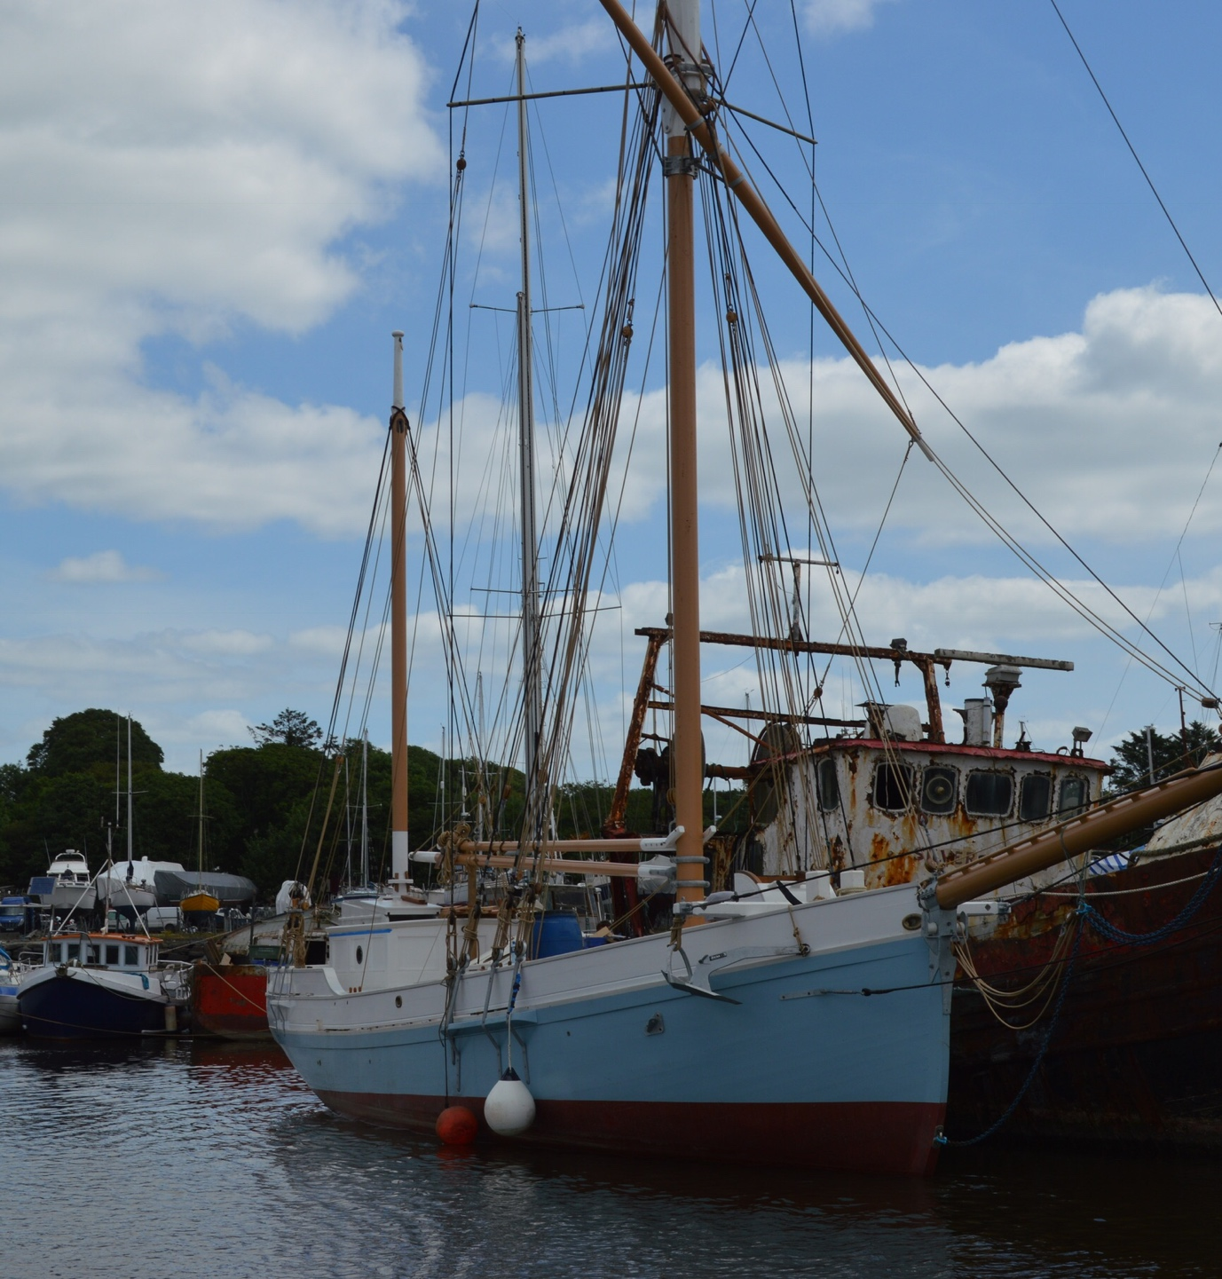
He welcomed us on board Ilen and explained she was aground on the slip but would be floating off shortly. The previous days were spent in bringing Ballast aboard but she was still floating high in the water. “Like a speed boat” he said with a smile. We looked around the little ship and it was as magical as I had hoped. Fresh Blue topsides and clean white decks. Shiny varnished spars and cream running rigging. Hardwood deadeyes and spliced steel wire rigging. Very long bowsprit and big anchors. The tide came in, she floated off and then we motored around to tie up outside the rusty trawler. I manned one of the fenders to be useful. We actually had a short voyage on the Ilen!!! I went ashore again to see and photograph the work on the Saoirse, another magical build. It was fantastic to see around both boats and in the sunshine too.
Mission accomplished, it was time to go home. Leaving near the top of the tide, we set off down river and went out to North harbour on Clear Island to see the marina. I think my kitchen might be bigger but it was beautiful. We didn’t stop but spun round and headed out. Neither Chris or Colin had been round the Fastnet before so that was the next waypoint. 1415 sails on to sail out round the rock. Glasses out to toast the rock. Wind was light so up went the spinnaker as an asymmetric as I don’t have a pole. We were a bit giddy with the emotion of completing our mission and with the Jameson Signature Malt Colin had brought me. The wind faded, the kite came down and we continued on towards Castletownsend. We sailed slowly in the light breeze and had a fry off the Stags. 2000 anchored and dinghy launched. To work up an appetite, I marched the crew right up to the top of the hill and then called into Mary Anns for Guinness on the way down. The outboard would not work but I had plenty of energy to use up!
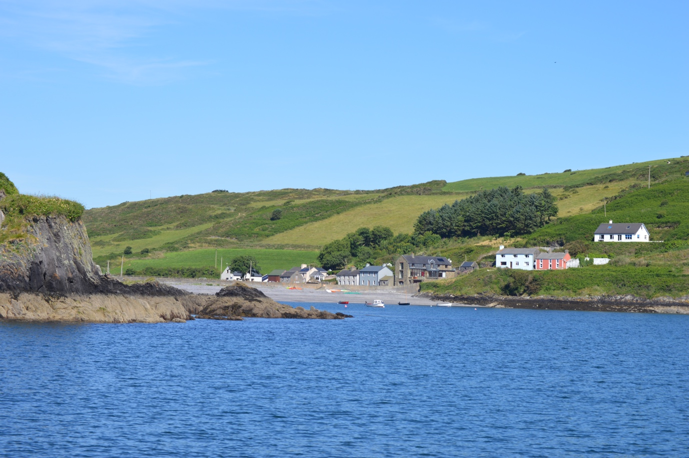
Friday the 22nd of June. Where did the month go? It was Colin’s last day. When I sailed round Ireland in 2013, I didn’t have time to explore any of west Cork. I had one day to do it all this time. So it was 0900 up anchor and away. Morning tea in Castletownsend. Cereal in Blind Harbour, (below) beautiful for family holidays with a kayak. In to Squince Harbour for a 2nd cuppa. Left Squince Harbour and passed Rabbit island with the stack of beans at the end. (well fed rabbits). In to Union Hall where my friend Len has his mooring. Out again and over to Glandore to admire the Dragons.
Blind Harbour.
Our second set of Dragon boats on this cruise. Left Glandore for Galley Head where galley slave Chris produced great bacon baps. The engine was turned off and sails on as we had wind for about an hour and a half. Peacefully passing Seven Heads. 1445 sails off again as we motored into Courtmacsherry in warm sunshine. Guinness in the lighthouse(bar), a Magnum icecream and back aboard. A perfect summer day. You are thinking this is too good to be true. Nobody deserves this much pleasure. You were right. We picked up a pot line and it was well stuck round the rudder, held in place by the pickup buoy. We caught the rope and pulled it up and tied it off to a stern cleat. Hauled in the rope with the buoy from the other side of the boat and cut the rope. Tied the rope ends back together and cast off buoy and rope with no harm done. We were very glad there was so little wind and all was straightforward. No lifeboat required. I felt we had kept well clear from the buoy but obviously not far enough off. It will be great when fishermen learn to weight their pot lines. By 1800, we had rounded the Old Head and had found Hole Open Bay. We went in, took the photo to show daylight on the other side and came out again. Could our day get better? Yes of course. As we came alongside in Kinsale marina, there were no spaces. We asked permission to tie up alongside a big blue boat. It turned out to be ICC member Liam Shanahan with his new Oyster 625 Ruth 2. I took his rubbish along with my own up to the skip at KYC. We were invited for G and T with Liam and his wife Ruth before we went our separate ways for dinner. What a beautiful ship. We presented him with an ICC burgee for his imminent trip to Galicia. We went for Colin’s last night to dinner in the Supper Club, a new Kinsale restaurant. We met the owners Tom and Grainne. Her Mum is from Portaferry. Food was excellent. I had to take the boys to The Tap tavern for a pint. Colin was teased mercilessly by the locals for his intense sunburn. Colin did not mind one bit.
Saturday 23rd. Colin said farewell and took a taxi back to Cork Airport. Our sporting trip continued as we watched Ireland beat Australia on TV in KYC. We then left and explored Oyster Haven in more sunshine. It was very busy so we continued onwards. Listened to Lewis Hamilton on the radio as we returned again to RCYC. The Mercedes team were 1st and 2nd in Qualifying for the next days F1 Grand Prix. Back in RCYC, we watched England beat South Africa in the rugby so Chris was happy again.
Sunday 24th June brought yet more sunshine. We took the bus to Carraigaline and walked back along the old railway line past Drakes Pool back to Crosshaven. I forgot to bring a drink for the walk but Molly has a coffee caravan at the start of the walk. She makes great coffee. Back at the marina, I saw Mary and Len Curtain ICC and invited them aboard for lunch. They headed off and Chris and I watched England win again, 5-0 against Panama. And Lewis Hamilton won the French Grand Prix. Vettel didn’t! Happy days.
The last crew change happened on Monday 25th when Brian and Heather arrived by car from Lisburn and Chris left, taking their car back to Belfast. Brian was my best man over forty years ago and I was his. We have been sailing ever since. This time he persuaded his wife Heather to join us for the return to Strangford. The weather was settled with sadly a very light northerly wind forecast for the week ahead. We left RCYC for the last time at 1630 and arrived in Kinsale at 1930. The electronic log has been misbehaving by exaggerating our distance run. We checked and measured and concluded it is showing 10% more than it should. It will be calibrated and reset when we get home. For coastal sailing in sight of land most of the time it doesn’t bother me too much. We were sitting in the cockpit having dinner and drinking Chablis while watching the guy on the opposite boat tidying up to leave. We offered him some refreshment but he refused as he was driving. He was flying off to Iraq the next day so gave us his unfinished bottle of wine, more Chablis. Very kind. I hope he has stayed safe.
Tuesday 26th brought more very light northerlies as we left for Kilmore Quay at 0600. Brian is an early riser so I had company for the early part of the morning. After a few cups of tea, is was suddenly 0830 and time for cereal. We like to eat healthy! Oh Dear, almost no milk and it was a long way, (about 60 miles) to Kilmore Quay. Time for the very smart phone. I looked at the chart and the nearest town to our course. Ballycotton was most promising. I googled Ballycotton grocer and found the “Ballycotton Stores and Post Office” Facebook page. I clicked on the telephone number and had an immediate reply. I asked if it was far to walk from the stores to the end of the pier and was told about 15 minutes. I didn’t want to lose half an hour so I asked if I paid a delivery fee, could he please deliver 3 litres of milk to the end of the pier. He said there would be no delivery charge and he would be happy to send someone down. I asked for half a dozen croissants as well and he said he would put on the oven at once. I said I hoped to be in by 10am. He said no problem. At five past ten, we nudged up against a trawler and Brian went up on to the pier. No sign of van, no sign of milk or even the croissants. Five minutes later a lady did arrive with two blue plastic bags. Money changed hands and after ten minutes gassing, Brian arrived back on board. Mission successful. Breakfast was great.
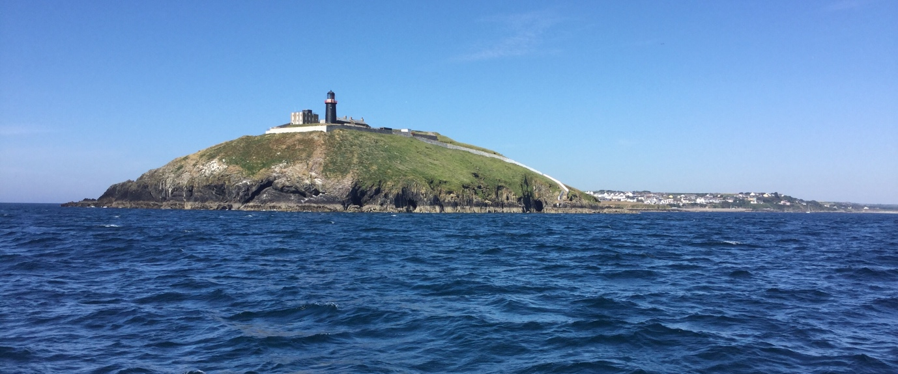
Ballycotton.

Heather doesn’t eat croissants so Brian and I did very well. An uneventful day after that took us to Kilmore Quay just in time to get a table in the Silver Fox. My turbot was again wonderful.
Wednesday 27th morning looked great for a walk along the path to the beach. Just long enough to work up an appetite for scones and jam with our Coffee. There is a very good chandlers in behind Kilmore Quay so I bought a better radar reflector. We filled the boat with fuel and set off after lunch. We sailed to Carnsore point and then kept the main on until Rosslare. I spoke to the Stena ferry on the radio to say I would pass astern of him. I had a very nice polite reply. I later tried to speak to the Irish Ferries Oscar Wilde but I was ignored. The great sunny weather allowed me to look for eddies very close in to beat the tide and to come out to catch the flood. We arrived in Arklow after 7 ½ hours instead of 8 hours on the way down. We tied up just after the boats came in from racing and had some friendly chat with them.
On Thursday 28th morning we slipped away from the J122 inside us on the pontoon. I had my 21st birthday in Arklow in the old harbour basin. We took a nosey in to look around but found it full of smelly fishing boats. We are better on the pontoon on the river. Another 0630 start to get well north. I had to be home for a garden party on Sunday. More sunny weather with the wind right on the nose. The tide allowed us to slip in to Malahide at 1250. A great walk on the beach again, a snooze and dinner in the center of the village in McGoverns. Great Duck well cooked. Brian and Heather really like Malahide and will come back by car.
Friday 29th morning the tide was out and we had to wait to leave. Talked to a man restoring an old Fairey Motor boat. He was struggling to get one of the huge engines to start. He was not a happy boy. I was keen to start my journey onwards and northwards. Again the wind was on the nose.
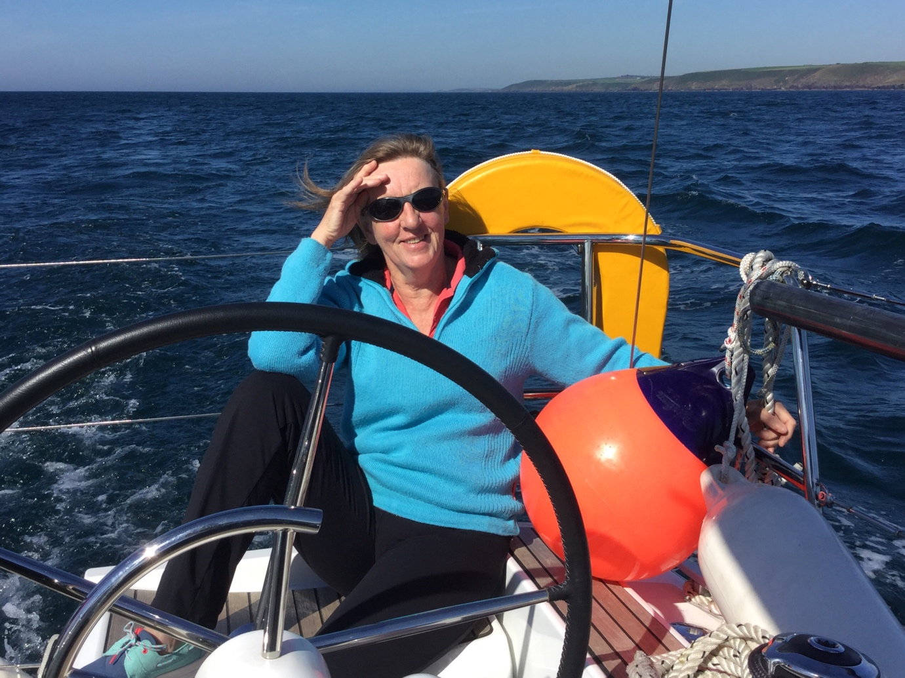
We took a few hours sailing hard on the wind along the shore towards Dundalk before giving in to good sense and motoring straight towards Saint Johns Point. For hours we admired the Mourne mountains with my Fathers house above the beach near Annalong in the middle of our view. Eventually we motored into Ardglass and were just in time to get the last table in Aldos restaurant. A fine dinner before our last night on board. I knew I was home when I knew half the people in the restaurant.
My wife Paddy came out to Ardglass for the last leg of the cruise home to Quoile. A fair weather sailor, she did not enjoy the very lumpy passage to Strangford Bar. Once we were into the lough and the smooth water, she was busy preparing a home cooked breakfast to welcome us back. We stopped at the pontoon in Strangford village to buy a new gas cylinder in Duffys and to eat breakfast. There was coffee as we passed Audleys castle and stories of our trip until we arrived back at the Quoile. Approximately 800 miles, mostly under engine but some stunning sailing. Four rivers explored, including the run into Courtmacsherry. New marinas and some old ones, new friends and old. A very good cruise. Thank you crew.
Peter Mullan

